Lab Week 4 Case Study Sample Solution

## 1a. Domain class diagram

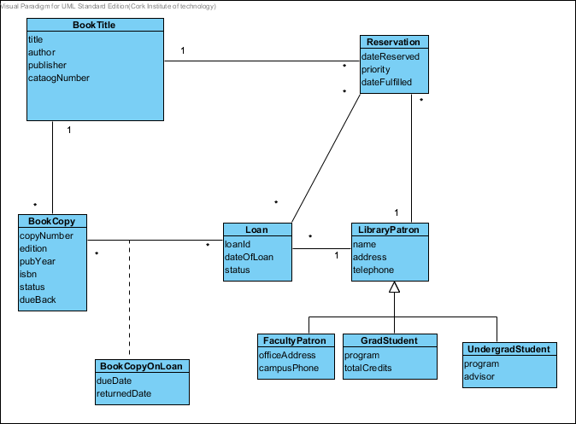

## 1b. Use Case Diagram

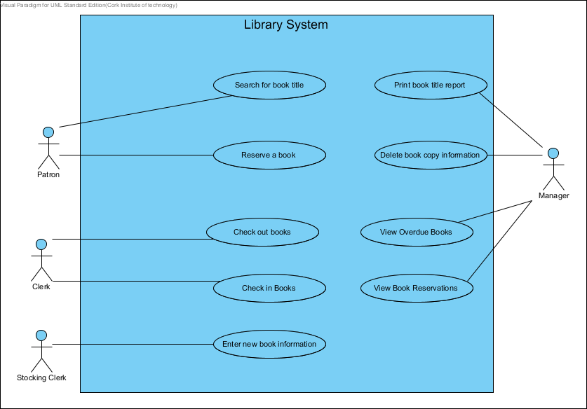

## 1c. CRUD analysis

|  |  |  |  |  |  |  |
| --- | --- | --- | --- | --- | --- | --- |
| Use Case | Book  Title | Book  Copy | Loan | Book  Copy  onLoan | Patron | Reservation |
| Search for book title | R | R |  |  |  |  |
| Reserve book |  |  |  |  |  | C |
| Check out books |  | U | C | C |  | U |
| Check in book |  |  | U | U |  |  |
| Enter new book information | C | C |  |  |  |  |
| Print book title report | R |  |  |  |  |  |
| Delete book copy information |  | D |  |  |  |  |
| View overdue books |  |  |  | R |  |  |
| View reservations |  |  |  |  |  | R |
|  |  |  |  |  |  |  |
| NEW USE CASES |  |  |  |  |  |  |
| Update book information | U | U |  |  |  |  |
| Update Patron information |  |  |  |  | U |  |
| Correct reservation |  |  |  |  |  | U |
| Print loaned book reports |  |  | R | R |  |  |
| View Patron information |  |  |  |  | R |  |
| Remove book from library | D | D |  |  |  |  |
|  |  |  |  |  |  |  |
| END OF PERIOD CLEANUP |  |  |  |  |  |  |
| Remove old loan information |  |  | D | D |  |  |
| Remove old reservation information |  |  |  |  |  | D |